**Website Traffic Analysis**

**Phase 2: Innovation**

In this section you need to put your design into innovation to solve the problem. Create a document around it and share the same for assessment as per the instructions mentioned.

Consider incorporating machine learning models to predict future traffic trends or user behavior patterns.

**Dataset Link:**[**https://www.kaggle.com/datasets/bobnau/daily-website-visitors**](https://www.kaggle.com/datasets/bobnau/daily-website-visitors)

1. **Introduction**

In the digital age, web traffic analysis is a critical component of understanding user behavior and making informed decisions. Organizations seek to optimize their online presence and improve user experience. To achieve this, we propose enhancing website traffic analysis by incorporating machine learning models to predict future traffic trends and user behavior patterns. This innovation aims to provide actionable insights to decision-makers and empower them to make data-driven decisions.

1. **Problem Statement**

Traditional web traffic analysis tools provide historical data but often lack predictive capabilities. Organizations need a solution that can not only provide insights into current traffic patterns but also forecast future trends and user behavior. This will enable them to proactively adjust their strategies and resources to meet evolving user expectations.

1. **Proposed Solution**

**Data Collection and Preparation**

To implement this innovation, we will first focus on data collection and preparation:

* Data Sources: Collect data from various sources, including website logs, user interaction data, and demographic information.
* Data Cleaning: Clean and preprocess the data to handle missing values and outliers.
* Feature Engineering: Create relevant features that capture user behavior, session details, and traffic sources.

**Machine Learning Model Selection**

* The heart of the innovation lies in choosing the right machine learning models to make predictions:
* Traffic Forecasting: Implement time series forecasting models (e.g., ARIMA, Prophet) to predict future traffic trends based on historical data.
* User Behavior Analysis: Utilize machine learning models (e.g., decision trees, clustering algorithms) to analyze user behavior patterns and segment users accordingly.
* Integration with Cognos
* Integrating the machine learning predictions with IBM Cognos for website traffic analysis is a crucial step:
* Data Warehousing: Store the processed data in a data warehouse that can be
* easily accessed by Cognos.
* Real-time Data Sync: Establish a real-time data synchronization process to ensure that Cognos has access to the most up-to-date data.
* Custom Cognos Reports: Develop custom reports and dashboards in Cognos that incorporate machine learning predictions for traffic trends and user behavior.

**4. Benefits of the Innovation**

**The proposed innovation offers several benefits**:

* Proactive Decision-Making: With predictive insights, organizations can proactively adapt to changing trends and user behaviors.
* Enhanced User Experience: By understanding user behavior, organizations can improve website design and content to enhance the user experience.
* Resource Optimization: Predictive traffic trends enable organizations to allocate resources efficiently, ensuring they are well-prepared for incoming traffic.

**5. Implementation Plan**

**The implementation of this innovation will follow these steps**:

* Data Collection and Preparation (2 months)
* Model Development and Training (3 months)
* Integration with Cognos (2 months)
* Testing and Validation (2 months)
* Deployment and Ongoing Monitoring (continuous)

**Code:**

import pandas as pd

import matplotlib.pyplot as plt

import plotly.express as px

import plotly.graph_objects as go

from statsmodels.tsa.seasonal import seasonal_decompose

from statsmodels.graphics.tsaplots import plot_pacf

from statsmodels.tsa.arima_model import ARIMA

import statsmodels.api as sm

data = pd.read_csv("daily-website-visitors.csv")

data["Views"].plot(legend=True, label="Training Data",

figsize=(15, 10))

predictions.plot(legend=True, label="Predictions")

print(data.head())

**Output:**

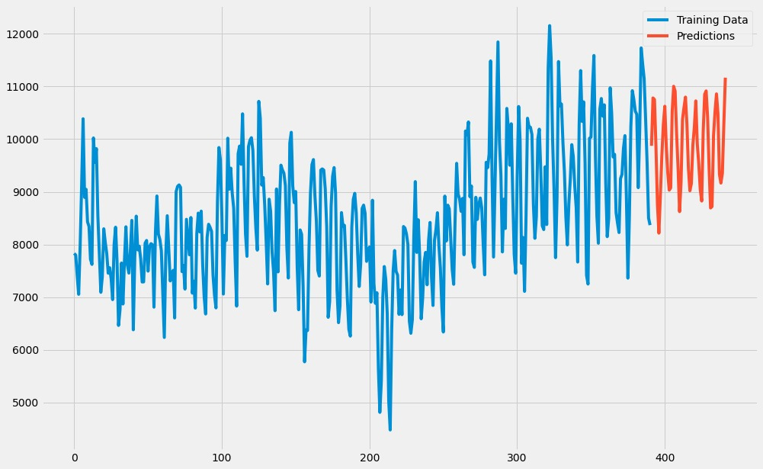

**6. Conclusion**

Incorporating machine learning models for predicting future traffic trends and user behavior patterns is a forward-thinking solution to enhance website traffic analysis. This innovation enables organizations to stay ahead in the competitive digital landscape, improve user experiences, and make informed decisions. By following the implementation plan outlined, we can unlock the full potential of this innovation.